 ABV-IIITM, GWALIOR

IT PROJECT

ASTRONOMY WEBSITE

Name: Sahibdeep Singh Sodhi

Roll No.: IPG-2015079

SPACE GEEKS

Space Geeks covers the breakthrough technologies and scientific discoveries that will shape humanity’s future. Our mission is to empower our readers and drive the development of these transformative technologies towards maximizing human potential.   
  
For us, exploring space is as much about the journey as it is the destination. So from skywatching guides and stunning photos of the night sky to rocket launches and breaking news of robotic probes visiting other planets, at SpaceGeeks.com you’ll find something amazing every day.  
  
Science and technology are transforming our society and fundamentally reshaping what it means to be human. From bipedal robots to quantum physics, from gene editing to flying cars, SpaceGeeks tracks the breakthroughs that are reshaping our future and leading us into a brave new world.

**Features used in the website**

JQuery and Bootstrap are used for the designing of the login page of the Space Geeks website. Various effects and animations such as transition effects on the background images are added.

When the user hovers over the text, a tooltip pops up.

For designing the home page of the website, CSS animation is used. The images rotates infinitely until the URL of the page is changed or replaced with some other URL. This feature adds creativity and attracts the end user of the website.

Basic HTML is used for designing the structure of the website and Javascript is used for the Web Forms embedded in the website.

**FEATURE 1- LINKING OF VARIOUS WEBPAGES**

Using href tag:

The href attribute specifies the URL of the page the link

goes to.

If the href attribute is not present, the <a> tag is not a

hyperlink.

For example-

<a href="index.html">Home</a>

<ahref=<https://en.wikipedia.org/wiki/>Space .com class="btn2">Click Here!</a>

**FEATURE 2-INSERTING IMAGES**

Using img src tag

The <img> tag defines an image in an HTML page.

The <img> tag has two required attributes: src and alt.

**Note:** Images are not technically inserted into an HTML

page, images are linked to HTML pages. The <img> tag

creates a holding space for the referenced image.

**Tip:** To link an image to another document, simply nest

the <img> tag inside <a> tags.

For example-

<img src="images/earth.jpg" alt="Img" height="204"

width="220">

<img src="images/spacecraft-small.jpg" alt="Img"

height="204" width="220">

**FEATURE 3- GETTING DATA USING TEXT BOX**

It is done using <input> tag

The <input> tag specifies an input field where the user

can enter data.

<input> elements are used within a <form> element to

declare input controls that allow users to input data.

An input field can vary in many ways, depending on the

type attribute.

For example-

<input type="text" value="Full Name“>

<input type="submit" value="Send Now" class="btn3"

onclick="fun_send(this.form)">

**FEATURE 4- USING ON CLICK EVENT**

The onclick event occurs when the user clicks on an

element.

For example-

<input type="submit" value="Send Now" class="btn3"

onclick="fun_send(this.form)">

function fun_send(form)

{

alert("Thankyou for Contacting Us");

}

SCREENSHOTS

Login page

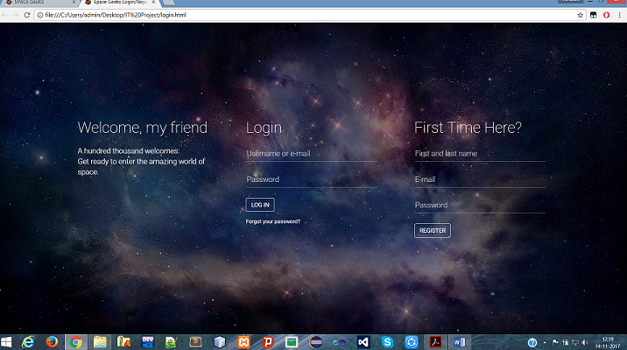

Home page

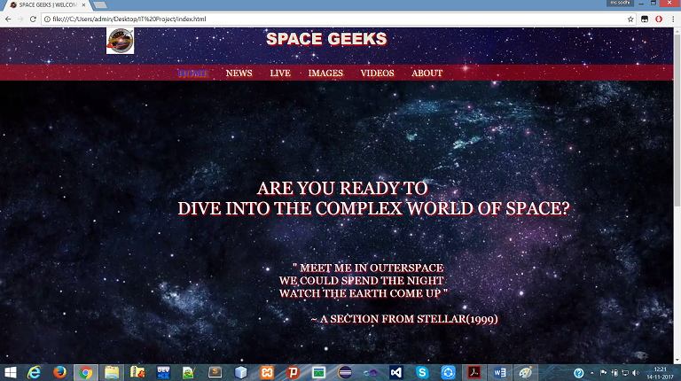

News page

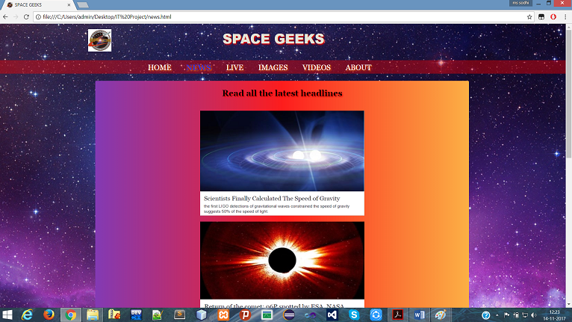

Images page

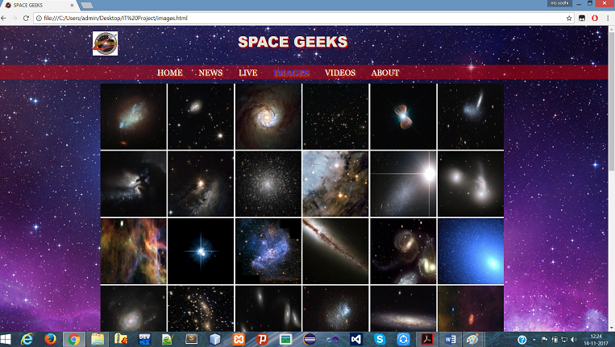

Videos page

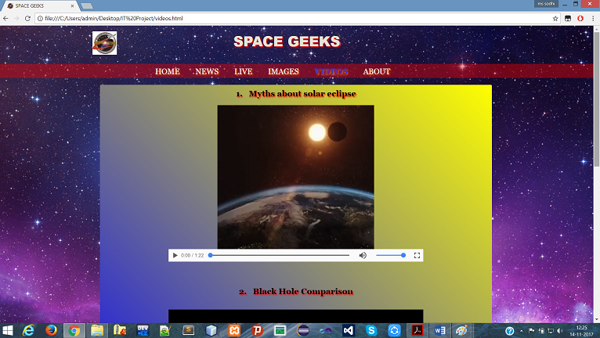

About page

